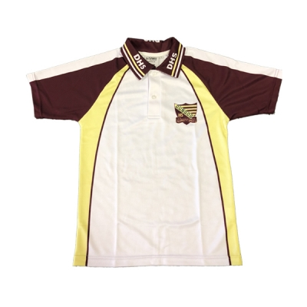
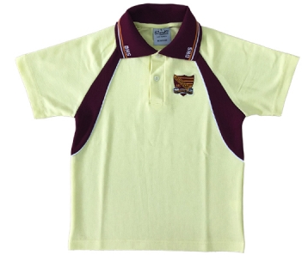
Jnr Polo (Lemon) Sport Polo

CHEST CHEST

LENGTH LENGTH
SIZE | CHEST CM | LENGTH CM
6 | 39.5 | 49
8 | 41.5 | 50
10 | 44.5 | 55.5
12 | 46..5 | 62
14 | 48.5 | 65.5
16 | 50.5 | 67
18 | 53.5 | 68
20 | 56.5 | 70
22 | 60.5 | 74
24 | 63.5 | 78
26 | 66.5 | 79
28 | 69.5 | 80

SIZE | CHEST CM | LENGTH CM
6 | 40.5 | 53
8 | 42.5 | 56
10 | 44.5 | 57
12 | 46.5 | 61
14 | 50.5 | 64
16 | 52.5 | 67
18 | 55.5 | 69
20 | 57.5 | 72
22 | 59.5 | 73
24 | 62.5 | 77
26 | 65.5 | 78
28 | 67.5 | 83

SIZE | CHEST CM | LENGTH CM
6 | N/A | N/A
8 | 41.5 | 56
10 | 44.5 | 57
12 | 47.5 | 63
14 | 48.5 | 65
16 | 49.5 | 66
18 | 53.5 | 67
20 | 55.5 | 69
22 | 57.5 | 73
24 | 63.5 | 75
26 | 64.5 | 77
28 | 67.5 | 77
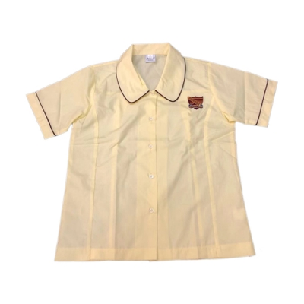
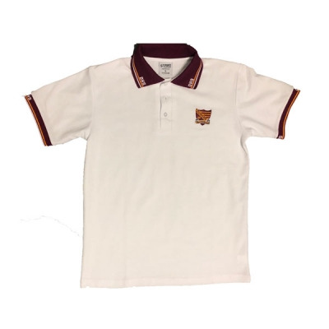
SNR POLO SHIRT JNR GIRLS BLOUSE

CHEST

LENGTH
SIZE | CHEST CM | LENGTH CM
6 | 44 | 54
8 | 48.5 | 57
10 | 50.5 | 59
12 | 52 | 60
14 | 55 | 62
16 | 57.5 | 64.5
18 | 61.5 | 66.5
20 | 65.5 | 69
22 | 66 | 70.5
24 | 69 | 74
26
28

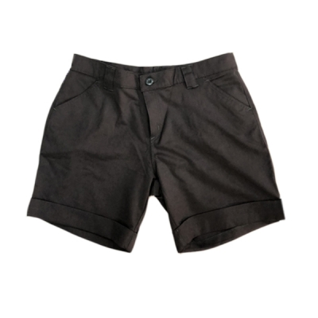
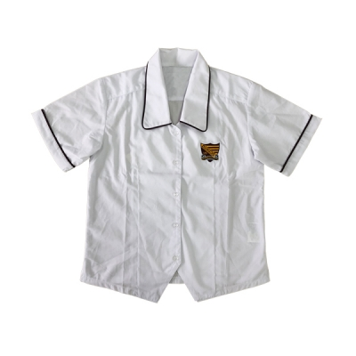
GIRLS SNR BLOUSE

SIZE | CHEST CM | LENGTH CM
6 | 44 | 54
8 | 47.5 | 55
10 | 50.5 | 57
12 | 54.5 | 57
14 | 55 | 58
16 | 56 | 59
18 | 59 | 60.50
20 | 60.5 | 62
22 | 62.5 | 62.5
24
26
28

SIZE | WAIST CM
10 GIRLS | 62
12 GIRLS | 64
8 WOMENS | 60
10 WOMENS | 65
12 WOMENS | 70
14 WOMENS | 75
16 WOMENS | 80
18 WOMENS | 85
20 WOMENS | 90
22 WOMENS | 95
24 WOMENS | 100

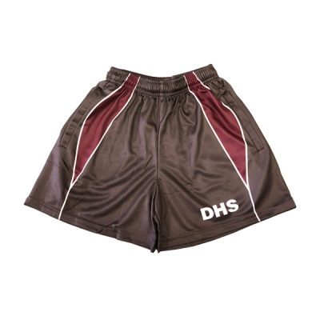
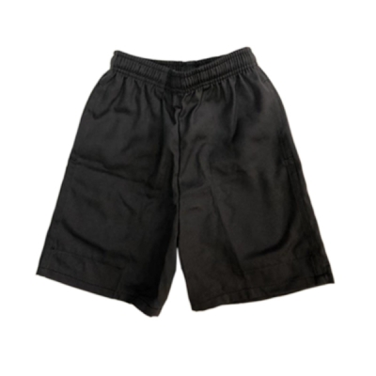

SIZE | WAIST CM
8 JNR | 60-62
10 JNR | 62-64
12 JNR | 64- 68
14 JNR | 68- 72
16 JNR | 72-76
SMALL | 75-80
MEDIUM | 80-85
LARGE | 85-90
X LARGE | 90-95
XX LARGE | 95-100
SIZE | WAIST CM
6 | 55-60
8 | 58-63
10 | 60-65
12 | 64-69
14 | 68-73
16 | 75-80
18 | 78-83
20 | 80-85
22 | 84-89
24 | 86-91
26 | 91-96
28 | 93-98

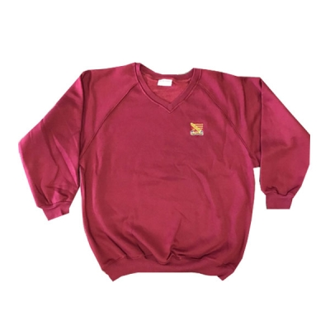
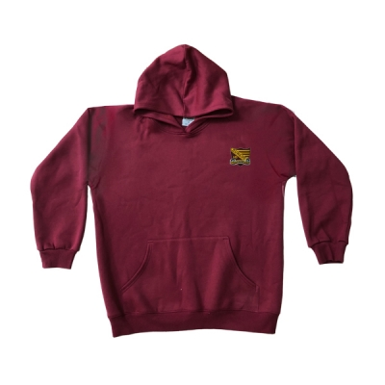
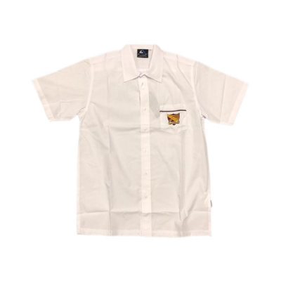
SNR BOYS BUTTON UP SHIRT V-NECK FLEECE JUMPER/ HOODIE

SIZE | CHEST CM | LENGTH CM
12 Jnr | 50 | 64.5
14 Jnr | 53 | 69.5
XS | 55 | 57
S | 57 | 70
M | 58 | 72
L | 62 | 73
XL | 65 | 76
XXL | 67 | 78
3XL | 69 | 80
4XL | 71 | 81
SIZE | CHEST CM | LENGTH CM
8 | 46 | 57
10 | 48 | 59
12 | 50 | 61
14 | 52 | 64
16 | 54 | 67
18 | 56.5 | 69
20 | 59 | 71
22 | 61.5 | 73
24 | 64 | 75
26 | 66.5 | 77
28 | 69 | 79

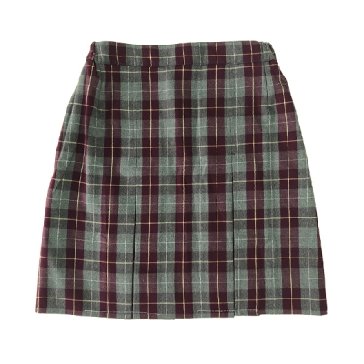
GIRLS SKIRT

SIZE | WAIST CM
2 | 64-66
4 | 66-68
6 | 68-70
8 | 72-74
10 | 76-78
12 | 80-82
14 | 82-84
16 | 88-90
18 | 90-92
20 | 92-94
22 | 94-96
24 | 102-104
26 | 106-108

